**Assignment- JOB Workflow**

Name: **E.R Harish**

Hands-on 1: Creating a job run with the sample load tutorial given.

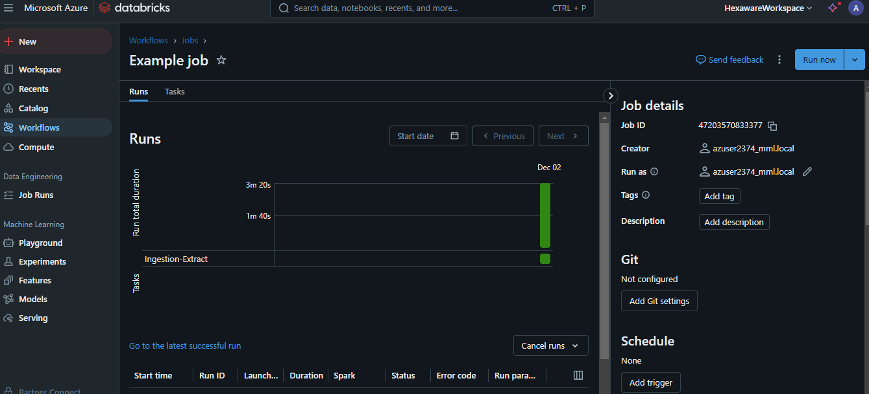

Output:

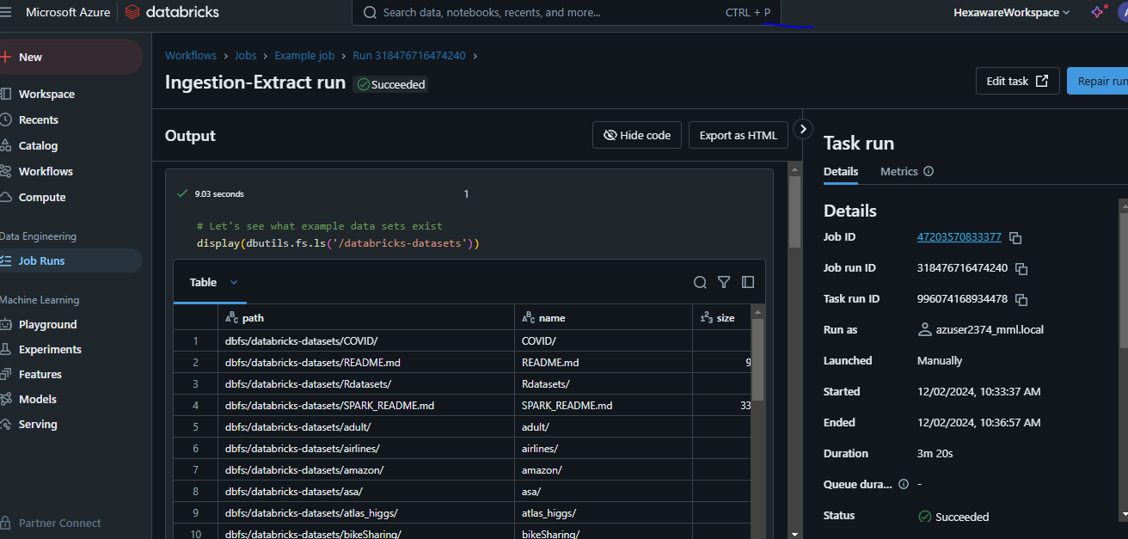

Hands-on 2: Creating a job run with the existing notebook.

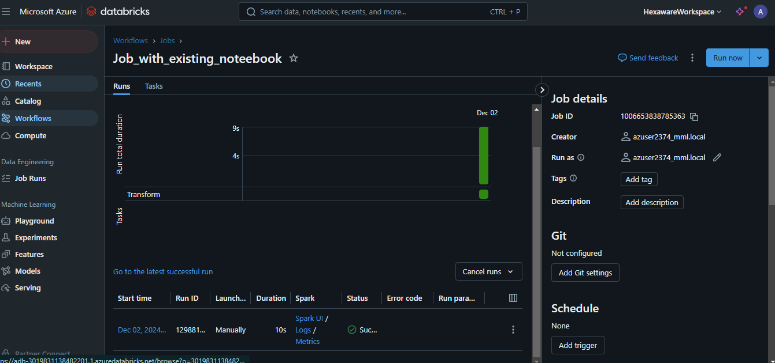

Output:

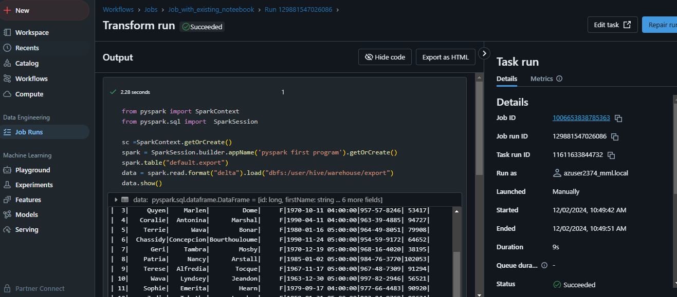

Hands-on 3: Creating a Storage Account.

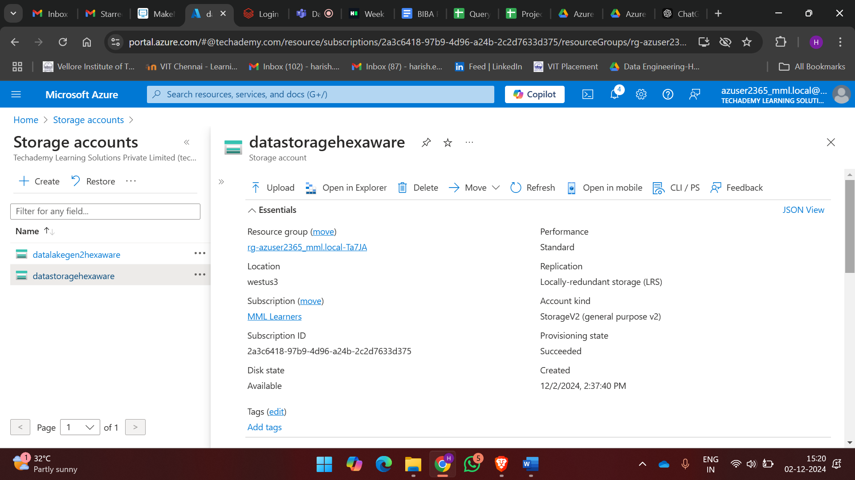

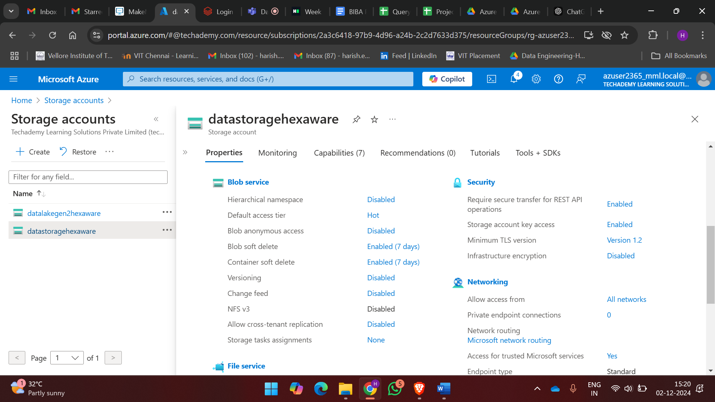

Hands-on 4: Creating a Data lake gen2 account.

